**Software Project Management Plan (SPMP)**

Table of Contents

**1.** **Introduction** 1

**1.1** **Project Overview:** 1

**1.2** **About the group:** 2

**2.** **PROJECT ORGANIZATION** 3

**2.1** **Software Process Model:** 3

**2.2** **Roles and Responsibilities:** 4

**2.3** **Tools and Techniques:** 4

**3.** **PROJECT MANAGEMENT PLAN** 5

**3.1** **Tasks** 5

**3.2** **Assignment** 6

1. **Introduction**
   1. **Project Overview:**

* **Problem statement**: There are many tools for both teachers and students to support learning process. However, there are not many easy and convenient tools to create and manage the test for teachers, which can help them build, store the questions. It also provide a library of varied and usual test.
* **Solution statement:**
* The Quizzes will provide a tool for teacher to add, edit and manage the quizzes of their own.
* The students can do quizzes to test the level or to see their progress.
* The Quizzes is available and free for everyone.
* **Positioning:** The Quizzes is a small module in Engrade – a larger system. Engrade provide a number of useful function for teachers to make quizzes, create lectures, manage classes and students. The Quizzes helps teachers to create quizzes containing multiple choices questions. Each quizz belongs to one of the academic subjects. The students can do quizzes of particular teachers, subjects. They can also choose a random. The Quizzes is free and available on the Internet as other parts of Engrade.
  1. **About the group:**
* **Member:**

Chu Viet Anh

Nguyen Tuan Anh

Do Quoc Anh

Ho Sy Viet Anh

Nguyen Van Chinh

* **Mentor:**

Dr. Truong Anh Hoang

* **More about the project:** It is the project in subject Software Engineering in University of Engineering and Technology, the result will cost 40% in the total grade point. The project lasts from week 2 to week 15 of second semester of year 2012.

1. **PROJECT ORGANIZATION** 
   1. **Software Process Model:**

The Quizzes uses **Incremental Model(IM).**

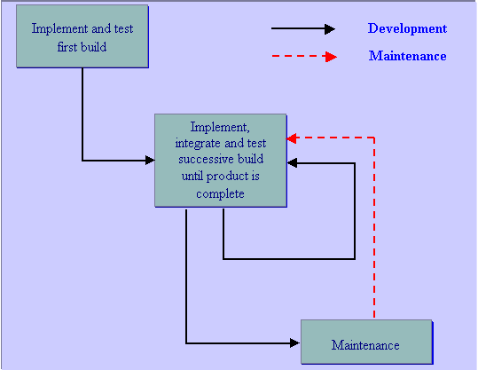

* 1. **Roles and Responsibilities:**
* **Lead developer:** Chu Viet Anh
* Hold the meetings among group
* Make the final decisions after discussing
* Understand and explain the specifications and requirements
* Code
* **Developer + Tester:** Nguyen Tuan Anh, Do Quoc Anh, Nguyen Van Chinh
* Gather enough information and understand the works
* Dicuss, ask and choose the best way for solving any problems
* Code
* **Designer:** Ho Sy Viet Anh
* Design and delegate the works
* Write documentation
* Support other members
  1. **Tools and Techniques:**
* **Tool:**
* Python, JavaScript, HTML… - Programming Language.
* Django – Framework.
* Freemind (Mindmap) – Design
* Yahoo, facebook – Communication
* **Techniques:**
* Brainstorming: Think and seek information
* Direct or indirect meetings: Talk and discuss
* Graphs and figures: Used to describe and express
* Feedbacks and comments: To improve and fix mistakes

1. **PROJECT MANAGEMENT PLAN** 
   1. **Tasks**

|  |  |  |  |  |  |
| --- | --- | --- | --- | --- | --- |
| **Task No.** | **Description** | **Deliverables and Milestones** | **Resources Needed** | **Dependencies and Constraints** | **Risks and Contingencies** |
| 1 | Main page, Register, Log in, Log out, Upload and change avatar | **W3**: Register and log in, log out complete  **W5**: Upload avatar  **W6**: Change avatar | Time, Coder and Django books | Depend on the available funtion of Django | Security problems |
| 2 | Creat a quizz which allows users to add questions and answers | **W6:** Create a quizz that show all the questions on the user’s page  **W10:** Only show the list of quizzes | Time, Coder, Djago books and other Materials from the Internet | Users add quizz in particular subjects | Hard to add ratio buttons.  Link of questions and answers can be modify by bugs |
| 3 | Allow users do a quizz | **W7:** users can do the questions of their own directly in the user’s page  **W11:** The users can choose a particular quizz to do, or a special quizz using random questions | Time, Coder, Materials from the Internet, Tester | Database design to support generating the random quizzes | The difficulties in generating random quizzes.  The questions and the answers of a quizz can be link wrongly |
| 4 | Send the user’s work to the database and get the result of quizz | **W10:** Get the result  **W12:** See the results over time | Time, Coder, Tester, JavaScript and Database knowledge | The score of each questions, the way to calculate the total score | The difficulty of recording the score over long time |
| 5 | Add funtions edit, delete quizzes | **W8:** Edit quizzes: delete and add questions, modify answers.  **W10:** Delete the whole quizz | Time, Coder, Tester, Database knowledge | A user can delete or edit only their own quizzes | Error when delete not complete all the questions in the quizz  If not careful, lead to chaos in database |
| 6 | Re-design the interface and the theme | **W13:** Complete the final interface | Time, Designer, Coder, Other materials | Base on the available funtions and knowledge | May meet some difficulties to re-link and re-order the functions |

* 1. **Assignment**
* **Task 1:** Nguyen Tuan Anh, Do Quoc Anh
* **Task 2:** Chu Viet Anh, Nguyen Van Chinh
* **Task 3:** Nguyen Tuan Anh, Chu Viet Anh, Ho Sy Viet Anh, Nguyen Van Chinh, Do Quoc Anh
* **Task 4:** Do Quoc Anh, Chu Viet Anh
* **Task 5:** Chu Viet Anh, Nguyen Tuan Anh, Nguyen Van Chinh
* **Task 6:** Chu Viet Anh, Ho Sy Viet Anh